1. Creating and Renaming Files/Directories

Create a directory named test_dir using mkdir.

cd /home/bob - - go inside the directory where you want to work on

mkdir test_dir - - to create directory with name test_dir

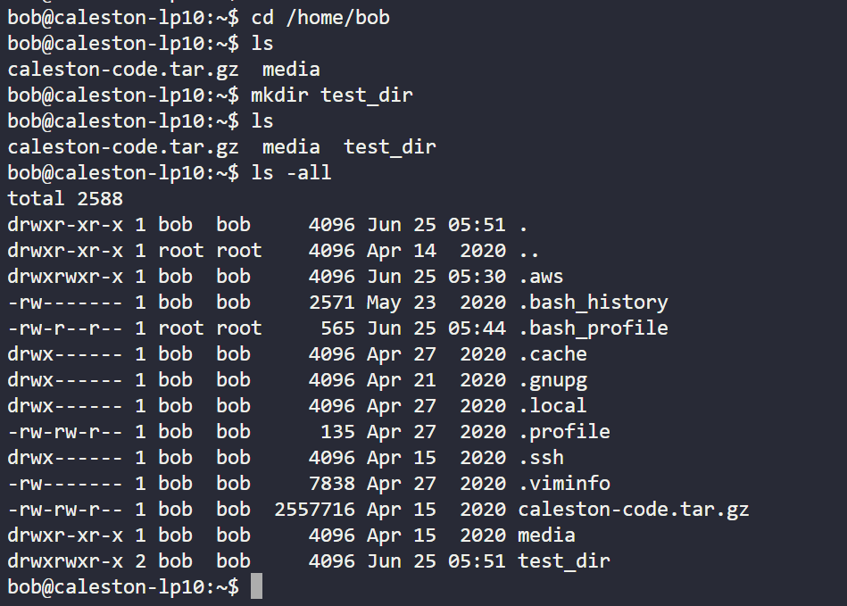

Inside test_dir, create an empty file called example.txt.

cd test_dir - - go into the desired directory

touch example.txt - - touch command use to create blank file

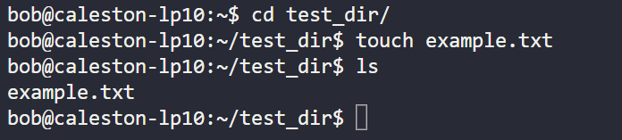

Rename example.txt to renamed_example.txt using mv

mv example.txt renamed_example.txt - - mv command use to move or rename - - mv [source file/folder] [destination path/ rename]

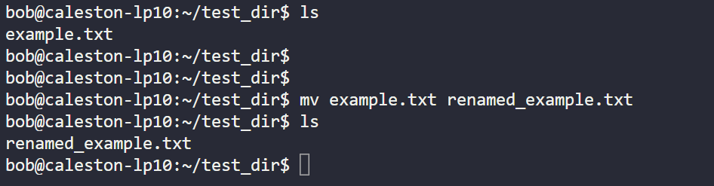

2. Viewing File Contents

Use cat to display the contents of /etc/passwd.

cat /etc/passwd - - to view entire file

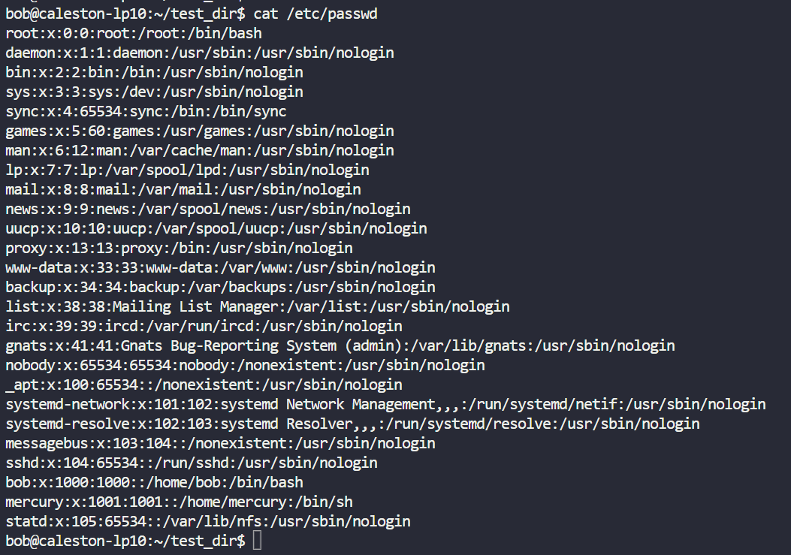

Display only the first 5 lines of /etc/passwd using head.

head -5 /etc/passwd - - to view only first 5, argument after head command will be number of lines you want to display

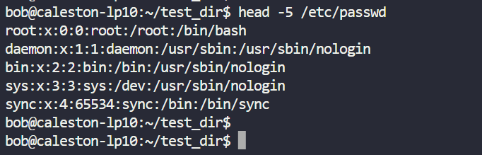

Display only the last 5 lines of /etc/passwd using tail.

tail -5 /etc/passwd - - to view only last 5, argument after tail command will be number of lines you want to display

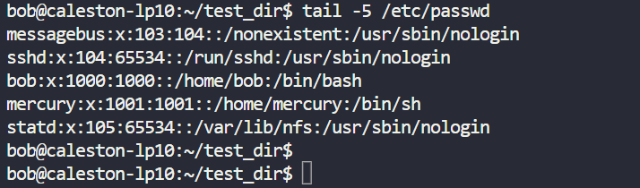

3.Searching for Patterns

Use grep to find all lines containing the word "root" in /etc/passwd.

cat /etc/passwd | grep -n root - - cat command is used to read the file and grep to search inside file with argument root

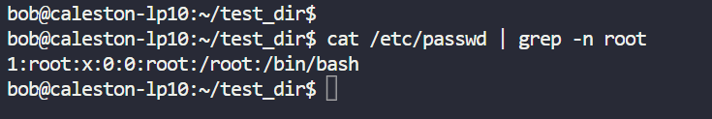

4. Zipping and Unzipping

Compress the test_dir directory into a file named test_dir.zip using zip.

cd /home/bob/

zip -s test_dir test_dir - - used to zip the file/folder

I do not have linux installed, in online free lab I do not have zip package, also can not install there

Unzip test_dir.zip into a new directory named unzipped_dir.

unzip -s test_dir.zip unzipped_dir - - unzip the file/folder

I do not have linux installed, in online free lab I do not have zip package, also can not install there

5. Downloading Files

Use wget to download a file from a URL (e.g., <https://example.com/sample.txt>).

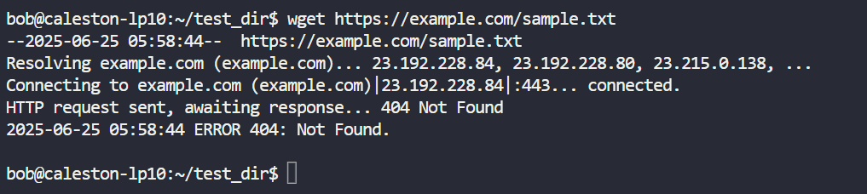

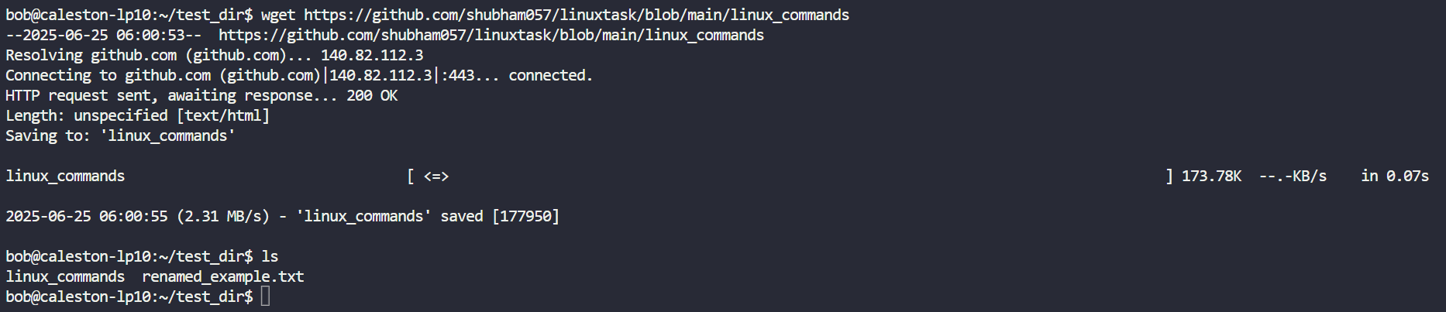

6. Changing Permissions

Create a file named secure.txt and change its permissions to read-only for everyone using chmod.

chmod 444 - - 444 used for r-r-r (read-only access for owner, owner group and rest users/groups

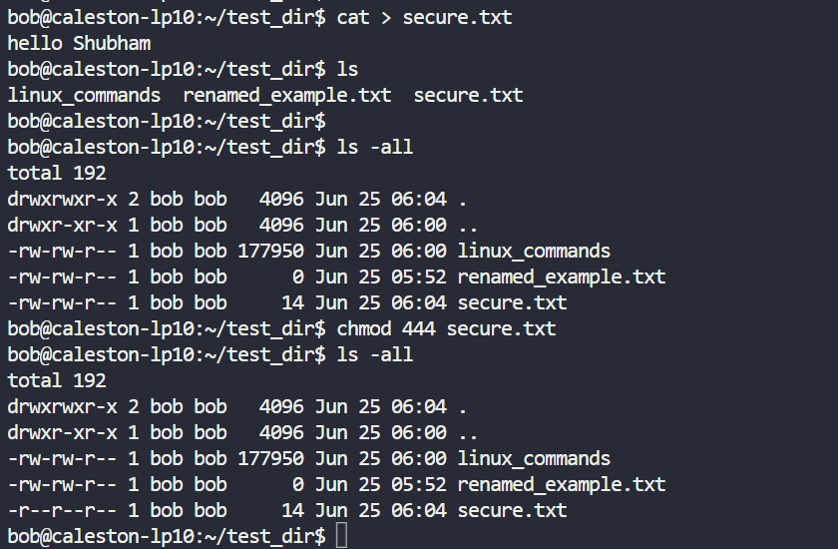

7. Working with Environment Variables

Use export to set a new environment variable called MY_VAR with the value "Hello, Linux!".

Used export command to create environment variable and echo $ to display the value of variable.

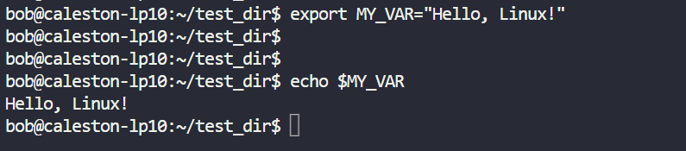

Git Hub repo : <https://github.com/shubham057/linuxtask/blob/main/linux_commands>